E-Commerce KPI Dashboard Insights and Recommendations
Q9) Write 3-5 Business Insights
Ans) a) The Total Sales is 23929524,Total Profit is 3764993,Average Order Value is 39883 and Profit Margin is 15.73
b) There is a negative trendline of Sales value for the upcoming months.Sales amount display the negative trends
c) South Region contributes to 27.866% of overall Sales,while North Region has the highest profit of 26.451%
d) Clothing Category contributes to 35.520% of Overall Sales.Jeans Product has the highest profit of 13.471%
e) When the discount value is 30,then there is zero profit,but when it is zero the profit is 31.37%

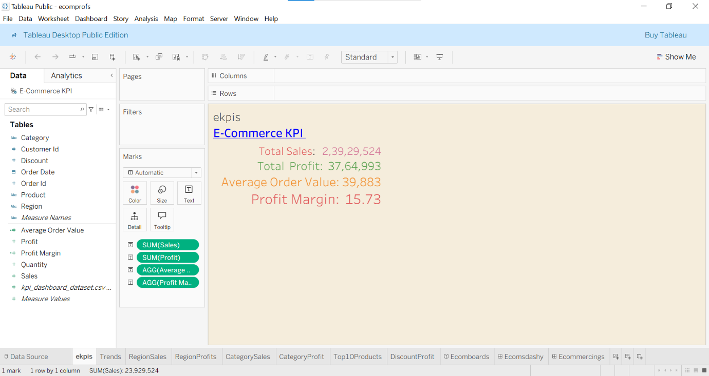

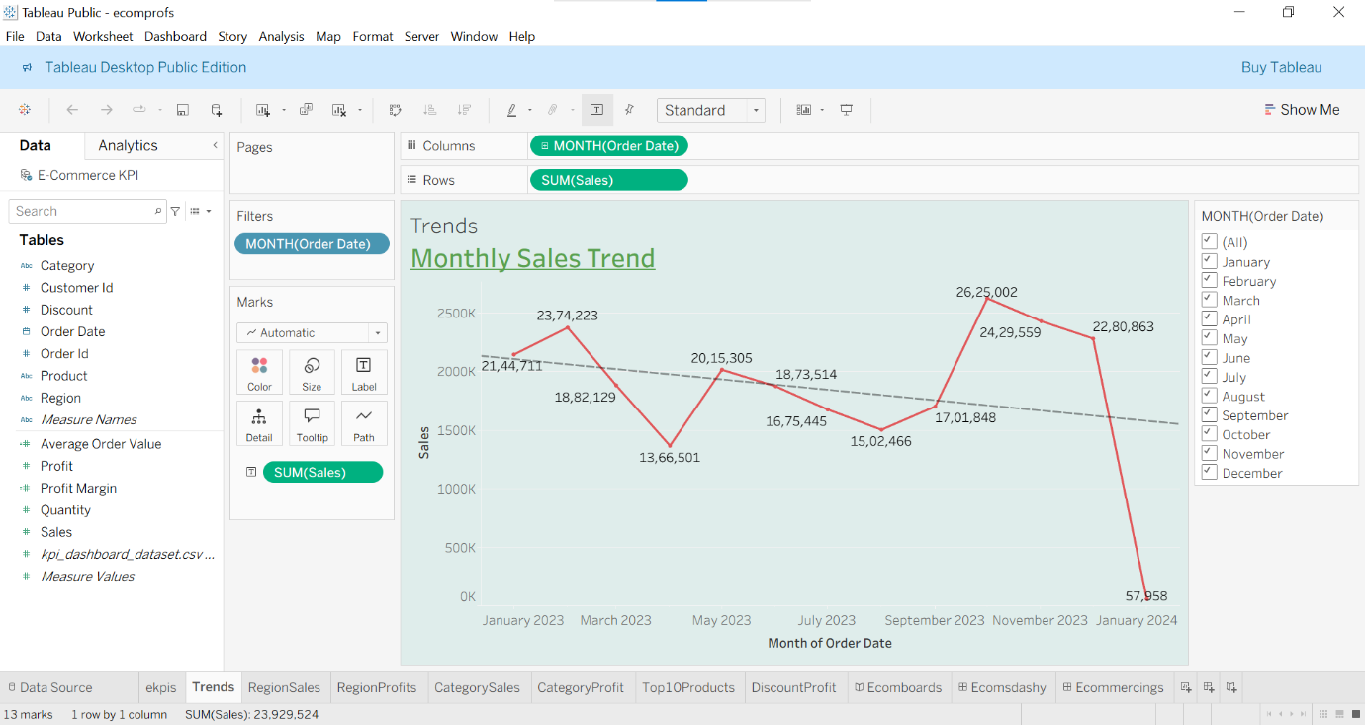

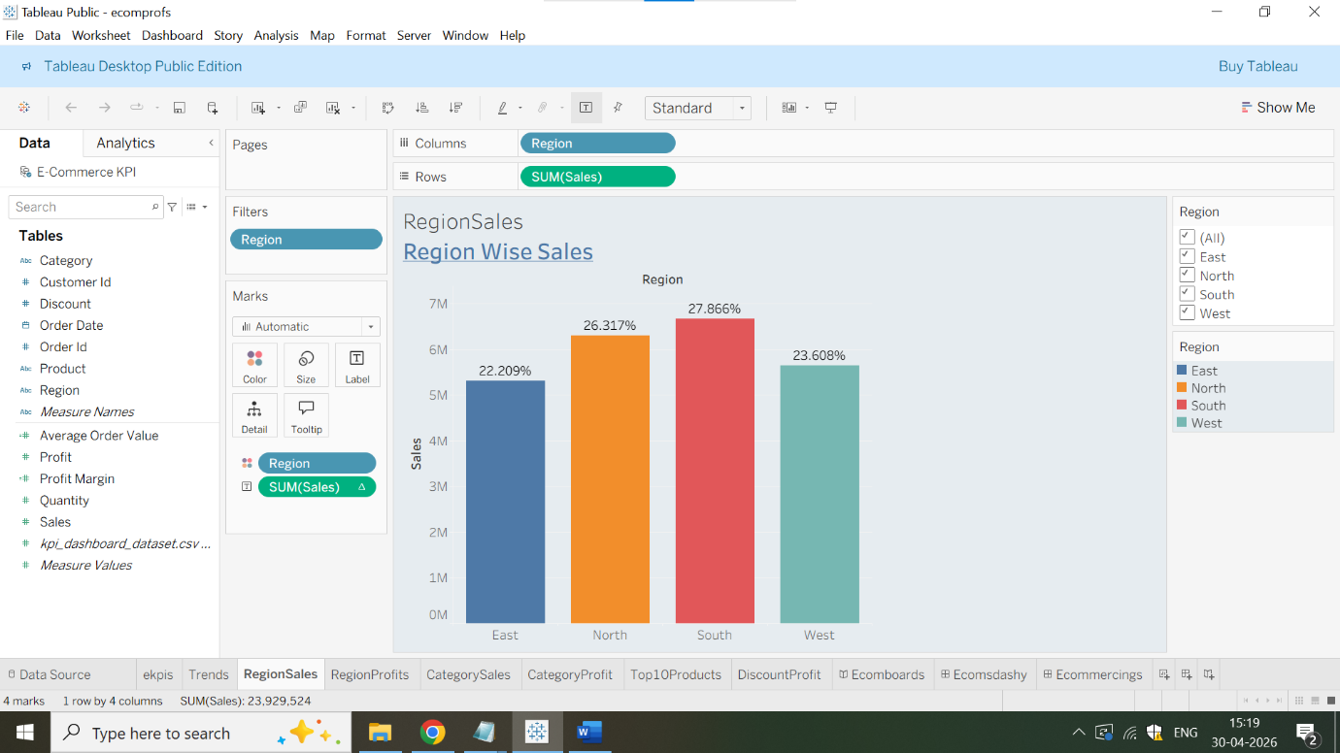

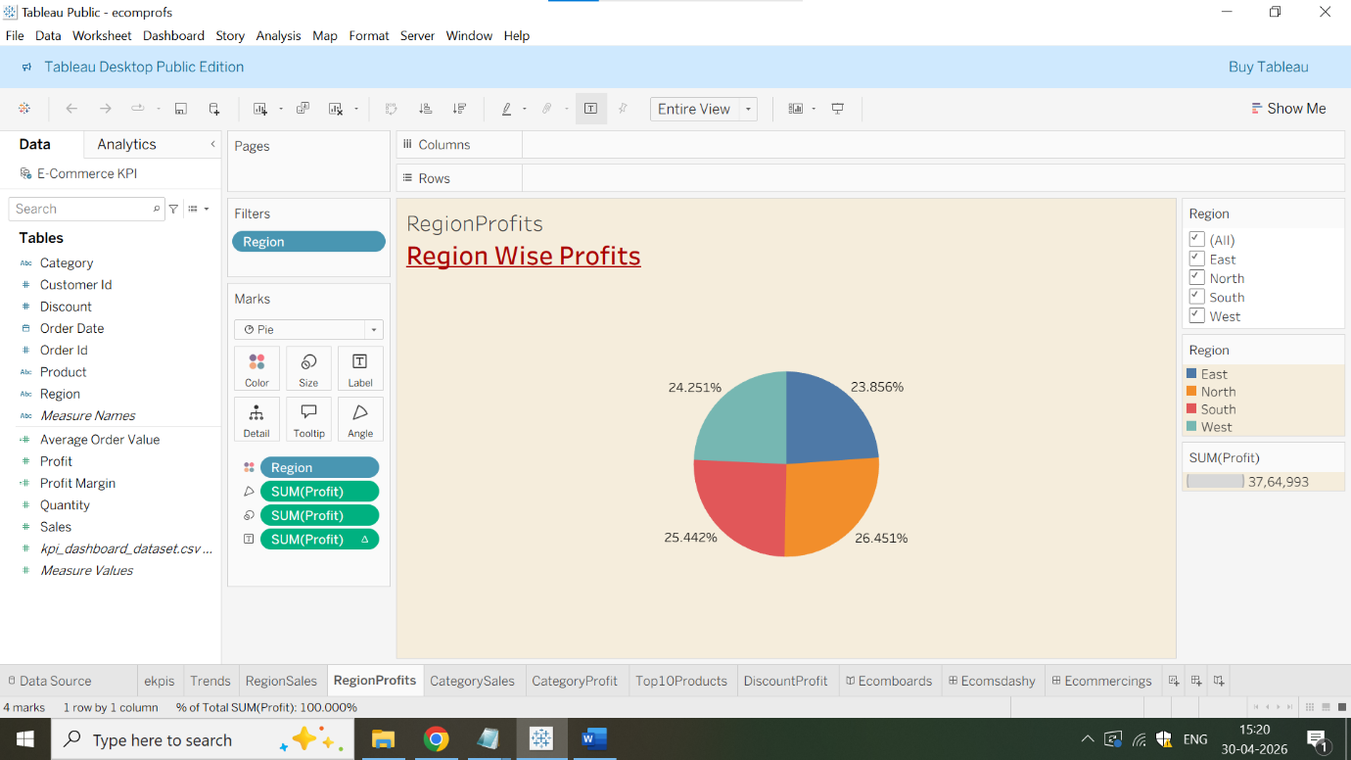

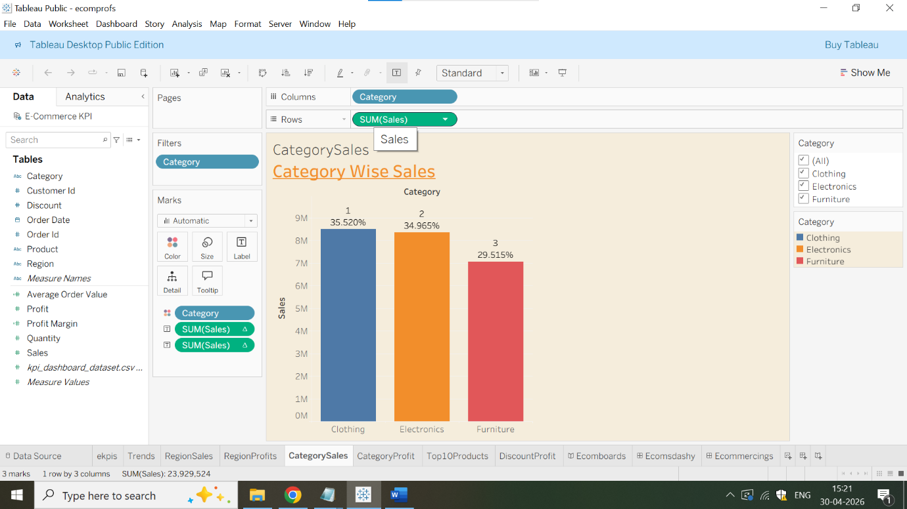

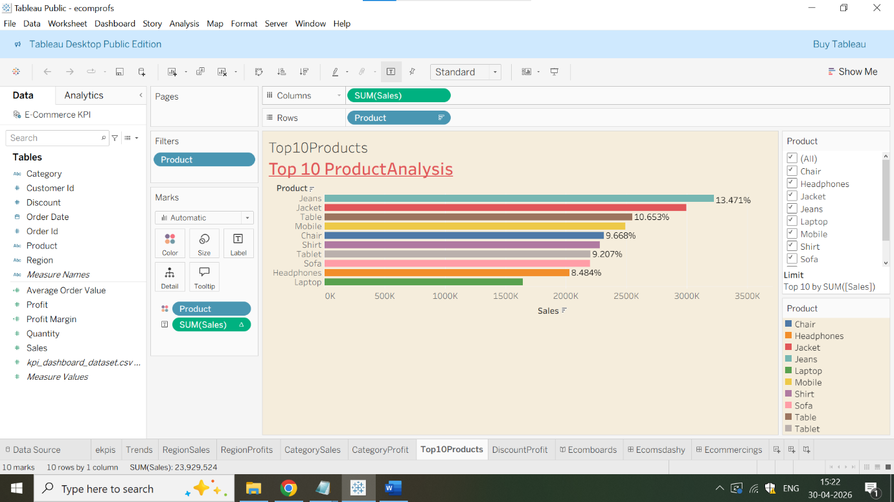

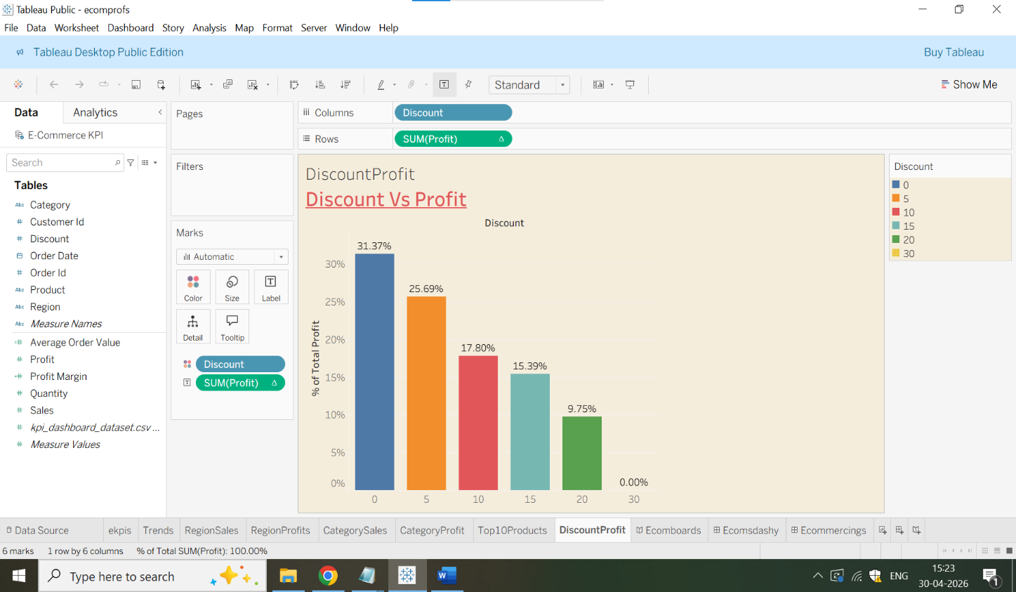

Q10) Suggest recommendations to improve profit
Ans) a) Heavy discount leads to zero profit.When the discount value is 30,then the profit is 0%,when the discount is 0 then the profit is 31.37%.Hence,company must minimize the discount amount in order to increase profit.Discount value should be in the range of 5-10 for maximizing profit
b) The Sum of Quantity Sold in the Year 2024 was 0.69%,but in the year 2023 was 99.31%.Ecommerce company must increase the total sum of Quantity sold for the consecutive years. It should be maximum not minimum.
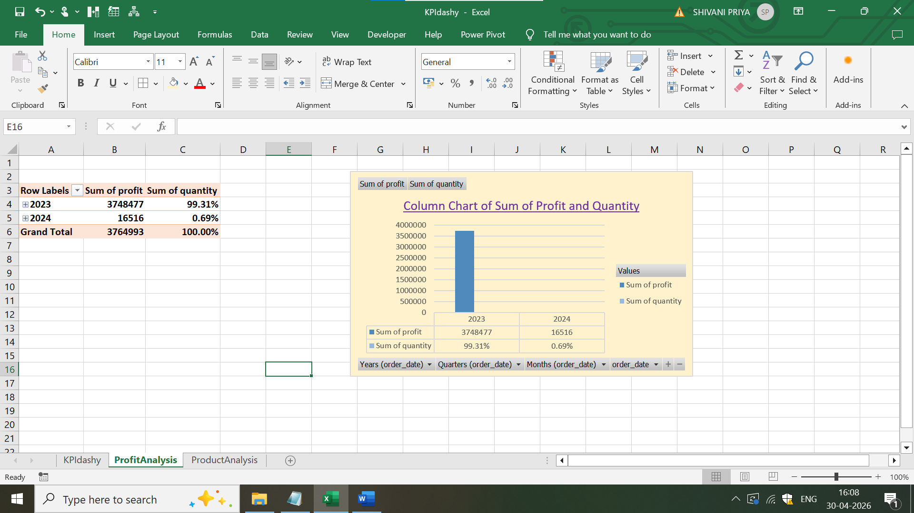

c) The highest profit in product category is of Jeans with sum of profit of 14.48% and sum of quantity of 211.Headphones product category has the least sum of profit of 7.36% and sum of quantity of 141.Hence,company must increase the sum of quantity of Heaphones,Laptop and Shirt for increasing profit
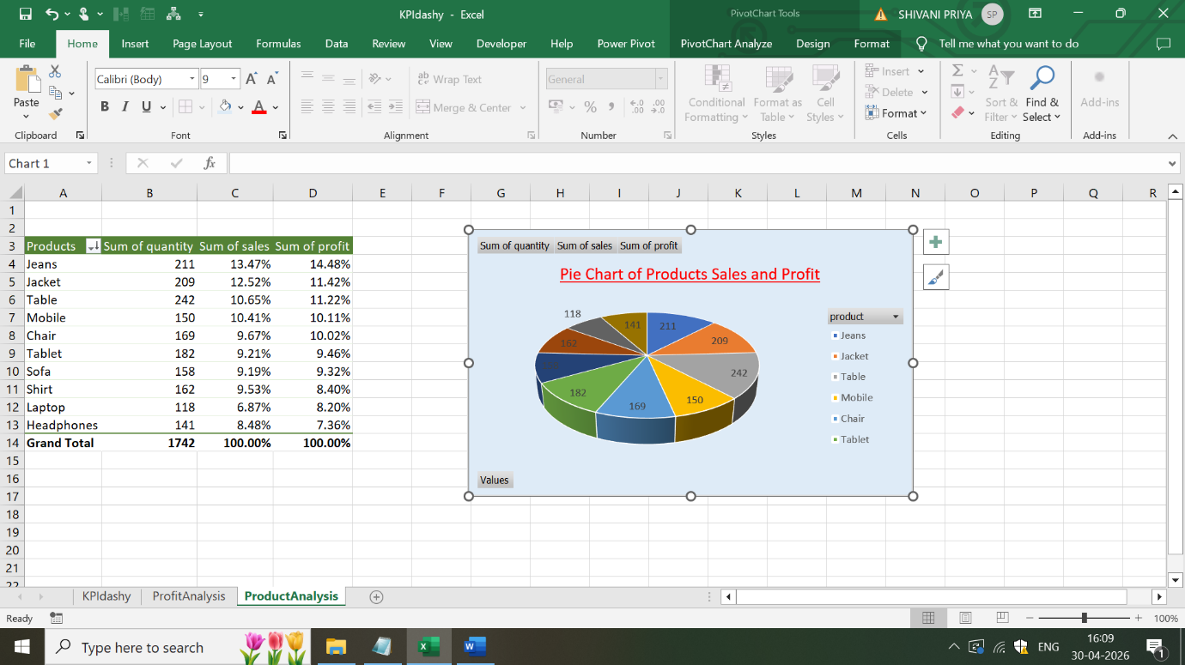

d) Customer Id 1771,1918 and 1899 are high value customers as these customer’s have given highest sum of profit of 1.05%,1.02% and 0.89%.Hence,ecommerce company can give some gift vouchers for customer retention
